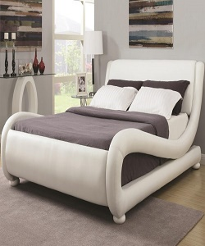

Modern Queen Upholstered Bed

$392.15

Availability: In stock

Description

White Leather Queen Size Bed - Steal-A-Sofa Furniture Outlet Los Angeles CA Add this white leatherette upholstered bed to any room in your house for a sleek and modern look.